**Assignment 3**

**Problem Statement:**

You work for a corporation. To maintain the security of the AWS account and the resources you have been asked to implement a solution that can help easily recognize and monitor the different users.

**Tasks To Be Performed:**

1. Create 4 IAM users named "Dev1", "Dev2", "Test1", and "Test2".

2. Create 2 groups named "Dev Team" and "Ops Team".

3. Add Dev1 and Dev2 to the Dev Team.

4. Add Dev1, Test1 and Test2 to the Ops Team.

**Solution:**

Step 1:- Create 4 IAM users as per the given name

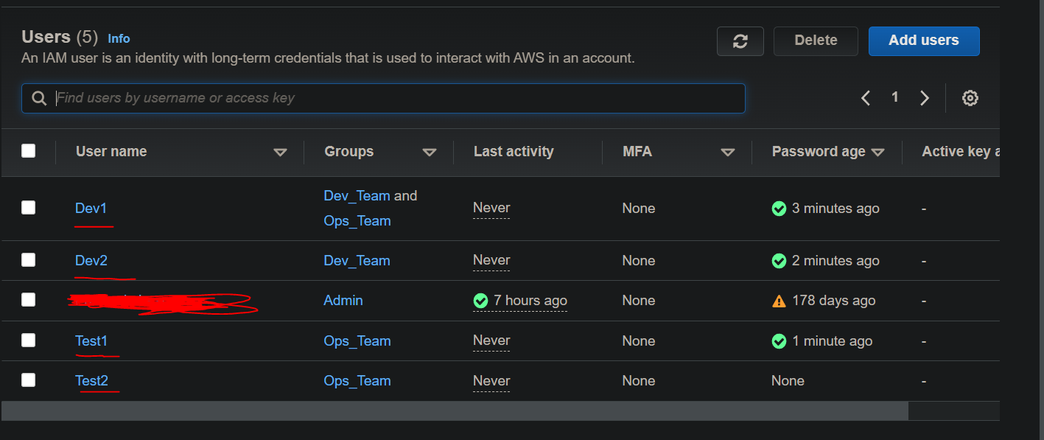

Step2:- Create 2 mentioned groups & add the users in their respective groups

